**Free-standing wire technique suitable for real-time profile reflectometer phase calibration on ITERa)**

L. Zengb), G. Wang, T.L. Rhodes, W.A. Peebles, C. Sung, R. Lantsov

*Physics and Astronomy Department, University of California, Los Angeles, CA 90095, USA*

Real-time phase calibration of the ITER profile reflectometer is essential due to the long plasma duration and path length changes during a discharge. Progress has been recently made in addressing this issue by employing real-time phase calibration on the DIII-D profile reflectometer system. By installing a thin free-standing wire which is perpendicular to the incident microwave propagation and near the end of the waveguide transmission system, the round trip phase shift from the wire is detected simultaneously with the plasma phase shifts. Variations in the reflectometer round trip path length (~26 m) can then be determined during each DIII-D plasma discharge, allowing the variation in the phase due to this movement to be accounted for. The round-trip reflectometer path length is observed to vary by ~3 mm (RMS value) during a DIII-D discharge. With the real-time correction, the measurement accuracy is improved. Since the wire retro-reflected signal is ~1/10 of the plasma signal, no effect is observed on the density profile measurement. Importantly, the wire calibration signal is approximately independent of the V-band reflectometer launch polarization, removing the requirement to change the wire orientation due to changes in the reflectometer launch polarization.

**I. Introduction**

Broadband frequency-modulated reflectometry has been widely used for electron density profile measurement1 due to the capability of high spatial and temporal resolution. As a short-distance radar-like technique, the diagnostic measures the round-trip phase or time delay of the millimeter-wave probe beam after reflection from plasma cutoff layers. The density profile is directly inverted using the plasma phase shift (from plasma edge to cutoff layers) after taking account of the transmission line vacuum phase shift. Typically the transmission line phase shift calibration is performed before or after the plasma discharge. However, for the ITER low field side reflectometry system (LFSR, is under development)2, the length variation of its very long transmission line (~39 m one way) due to waveguide and vessel thermal expansion will be significant. Therefore, real-time phase shift or phase calibration for the ITER profile reflectometry system is essential.

To address this issue, a real-time phase shift calibration has been tested and developed on the profile reflectometer system in DIII-D. The schematic is illustrated in Fig.1. This diagnostic includes both Q-band (33-50 GHz) and V-band (49-75 GHz) reflectometers with both bands simultaneously operating in both X and O-mode polarization. It utilizes a long (~26 m double-pass) low power loss circular corrugated transmission line (shown as a yellow line in Fig.1(a)) for each frequency band, as well as a monostatic antenna configuration3. A thin free-standing wire (1 mm diameter) is installed at the end of the transmission line of the system, as indicated in the schematic in Fig. 1(b). The wire is perpendicular to the reflectometer microwave propagation direction. When the reflectometer probe beam is launched into the plasma, a small retro-reflected signal from the wire is simultaneously generated along with the main reflected signal from plasma cutoff layers. The plasma phase shift can then be calibrated in real-time using the signal reflected from the wire.

A small variation of round-trip reflectometer calibration path length is measured (RMS value of ~3 mm) during a typical DIII-D discharge. Using the real-time correction, the accuracy of electron density measurement is improved. Since the wire retro-reflected signal is ~1/10 smaller than the plasma signal, no effect is observed on the plasma density measurement. Importantly, the wire calibration signal is approximately independent of the reflectometer launch polarization, allowing this polarization to be changed to match the plasma pitch angle.

In this paper, we describe the real-time calibration technique and development. The profile analysis with this real-time correction will be also presented. The remainder of this article is structured as follows: The technique of real-time phase calibration using a free-standing wire is described in Sect. II. Investigation of the reflected power dependence on wire diameter and reflectometer polarization is presented in Sect. III. Electron density profile analysis using the real-time calibration is described in Sect. IV. Finally, conclusions and future work are presented in Sect. V.

**II. The technique of real-time phase calibration by free-standing wire**

As mentioned above, profile reflectometry is a radar-based technique4 that measures the line integral phase shifts ** or equivalently, the time delay, *=(d/df)/2*, of electromagnetic radiation reflected from plasma cutoff layers as a function of the probing frequency *f*. The plasma phase shift in propagating from the plasma edge located at radius *R0* to the cutoff layer at radius *Rc(f)* and back is determined by the formula,

$ϕ_{plasma}=\frac{4πf}{c}\int_{R_{c}}^{R_{0}}{μ(R,f)dR}$ (1)

where  is the refraction index for the plasma and polarization utilized. The plasma phases are obtained by the total phase shifts, which are measured by the reflectometer, subtracting the vacuum phase shift in the path length (mainly in the transmission line),

 $ϕ_{plasma}=ϕ_{total}-\frac{4πfR}{c}$ (2)

a)Contributed paper published as part of the Proceedings of the 22nd Topical Conference on High-Temperature Plasma Diagnostics, San Diego, CA, 2018.

b)Author to whom correspondence should be addressed: zeng@fusion.gat.com

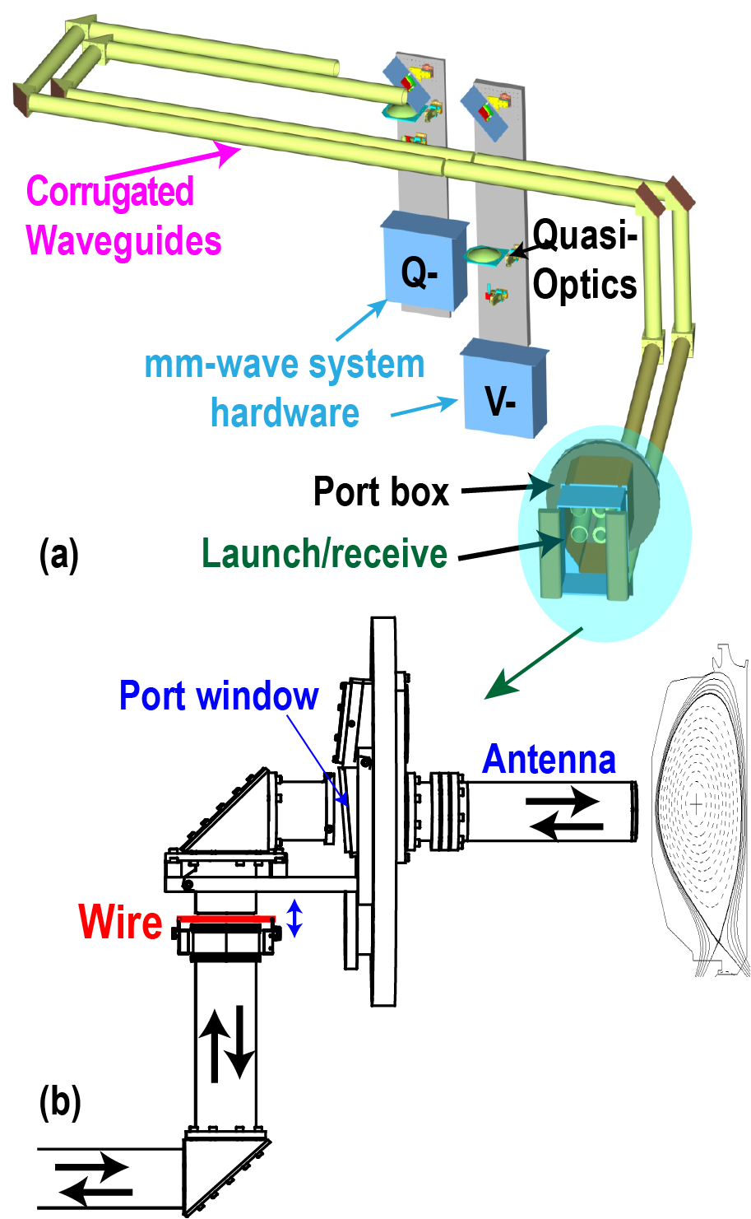

FIG. 1. Illustration of profile reflectometer system in DIII-D (a). The front-end shaded area in (a) is expanded in (b), where the installed calibration thin wire is shown as a red line.

profile is inverted using the determined plasma phase as a function of launch frequency1. However, the above equation clearly shows that any variation in the transmission line length during a plasma discharge will induce errors in calculated plasma phase shift and in the resulting density profile reconstruction.

To address this, a stainless steel thin wire with 1 mm diameter is installed in the front-end of corrugated waveguide, as displayed in Fig. 1(b) as the red line. Because it is perpendicular to the probe beam, the maximum reflection will be generated and coupled back into the transmission line. The wire is movable manually along the axis of the waveguide over a distance of 18 mm. This allows us to examine the sensitivity of the phase calibration. In Fig 2(a), the intermediate frequency of the V-band signal is shown in red during reflection from the wire as it is manually moved 18 mm over a 5-second period. In contrast, the black curve shows the spectrum for a static wire. It is clearly seen that the signal beat frequency varies by approximately 150 kHz as the vacuum path length is varied by 18mm. Because the movement is by hand, the red curve is irregular in shape. Actually according to the reflectometer intermediate frequency change, the variation of the wire location, i.e. vacuum path length difference can be determined by,

$δR=\frac{c}{2}\frac{{δf}_{wire}}{df/dt}$ (3)

, where fwire is the change of intermediate frequency of signal and df/dt is reflectometer RF frequency sweep rate. The responding result of R is illustrated in Fig 2(b). As can be seen the determined range variation of the wire is also ~18 mm, consistent with the actual moving range. This indicates the diagnostic calibration has excellent range resolution.

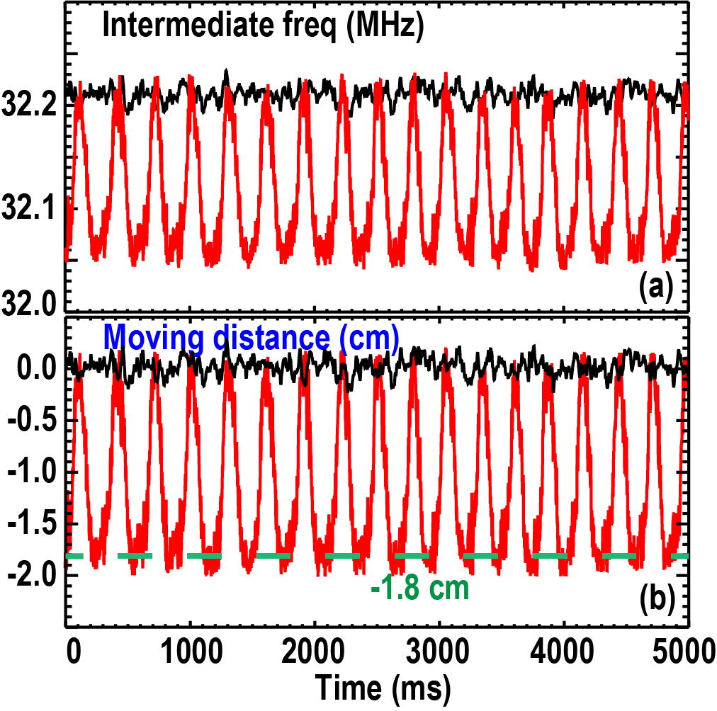

FIG. 2. When calibration wire is moved manually 18 mm axially, the variations of V-band reflectometer signal intermediate frequency in (a) and the responding measured wire location in (b) are shown as red curves. In contrast the static wire frequency and distance are shown as black curves.

During a plasma discharge, the wire position is static and not moved. When the reflectometer microwave beam (e.g. V-band X-mode) is launched into a H-mode plasma, the primary received signal reflects from the steep edge density pedestal. In Fig. 3, a frequency spectrum of full band sweep data is presented. It shows the intermediate frequency peak of signal reflected from plasma cutoffs, the frequency generated by scattering from the wire and a small frequency peak reflected from the port window. Although the port window is tilted at a 60 angle (as indicated in Fig. 1(b)), a tiny reflection can still be detected by the reflectometer mixer. Note that the frequency peaks from both the wire and window are well separated from plasma reflection intermediate frequency range (< 23 MHz for V-band X-mode data). Also, the amplitude of plasma signal is one order higher of magnitude larger than the signal scattered from the wire, so installing the wire doesn't interfere with plasma density measurement. In the next section, you will see the power of the scattered wire signal increases with wire diameter. The optimization of the wire diameter is necessary dependent on the frequency range.

It is interesting to see how large the path length changes during a plasma discharge. In Fig. 4, the beat frequency of the calibration wire signal (still using V-band X-mode), the calculated vacuum path length change, and the DIII-D plasma current are displayed. As can be seen the beat frequency variation during the plasma duration is significantly larger than the value after the discharge ends. This indicates that reflectometer path length changes during the plasma discharge. As displayed in Fig. 4(b), the path length change R can vary up to 5 mm, with ~3 mm RMS value during plasma discharge. It is also observed that there is a larger change in vacuum path length seen near the beginning of the plasma discharge. It is unlikely the path length change due to the thermal expansion of waveguide on DIII-D. Since the transmission line system contains two long corrugated waveguide pieces which are both mounted underneath the wood floor and there is a small gap in between, a small vibration along the axis of waveguide is likely generated during plasma discharge. Therefore, the vibration may cause the variation of vacuum path length. These results suggest that reflectometer path length possibly needs to be calibrated in real-time during discharge, in order to get a more precise profile measurement. We will present this result in Sect. IV.



FIG. 3. Frequency spectrum of V-band X-mode data, reflected from the edge density pedestal regime



FIG. 4. During a DIII-D discharge, the variation of the IF signals from the calibration wire is shown in (a), the vacuum path length variation in (b), The plasma current is shown in (c).

**III. Reflected power dependence on wire diameter and incident electric-field orientation**

In order to optimize this calibration tool, it is necessary to study the dependence of reflected power on the free-standing wire diameter and the wire angle to the incident probe beam polarization. In our first lab investigation for this, 70 GHz millimeter-wave radiation is coupled to an 8 ft. long overmoded corrugated guide followed by a miter bend and an additional ~8ft. section of corrugated waveguide. Wires of various diameters are alternately mounted perpendicular to the axis of the waveguide and the scattered power coupled back into the waveguide. The wire can also be rotated by 90 degrees so that it is either parallel or perpendicular to the coupled electric field. The return power is then measured as a function of wire diameter for both polarization orientations relative to the wire. The ratio of the powers ($p_{⊥}/p_{∥}$) for the orthogonal polarizations is plotted as a function of the normalized wire diameter, i.e. d/, where d is wire diameter and  is the incident wavelength. The results are illustrated in Fig. 5. When d $/λ≪1$, $p_{⊥}$ is much smaller than . As d/ increases, $p_{⊥}/p_{∥}$ increases dramatically until the normalized diameter d/ ≈ 0.2, where the ratio $p_{⊥}/p_{∥}$ is close to about unity. A similar dependence has been obtained for different millimeter-wave frequencies. According to calculations of plane electromagnetic wave scattering from a free-standing wire5, the scattering cross sections for both orthogonal directions depend on ka, where a is the wire radius and k is wave number of incident wave. Only when $ka≫1$, do both directional scattering cross sections become close to each other, i.e., $σ_{⊥}≈σ_{∥}∝4a$. The simulations explain why $p_{⊥}$ becomes close to $p_{∥}$ as the value of ka (equivalent to d/) increases. Moreover, the scattering cross section becomes larger as the wire diameter is increased. This suggests that a sufficiently large diameter wire (~ d/ > 0.2) is necessary in order to obtain retro-reflected signals from the wire that are approximately independent of polarization. Otherwise, the wire signal would be too small to be detected. According to our Fig. 5 laboratory experimental result, it is found that only d/    equivalent to ka ~ 0.6)  to achieve $σ_{⊥}≈σ_{∥}$ already. This may be related to how effective the radiation scattered from the wire couples to the dominant HE11 mode required for efficient propagation along the corrugated waveguide



FIG. 5. The free-standing wire reflection power ratio for the perpendicular polarization to the parallel polarization of incident 70 GHz millimeter-wave versus the normalized diameter wires (d/), by scanning different size of wires.

The retro-reflected power dependence of the incident millimeter-wave electric-field orientation relative to the wire direction was also investigated directly using the profile reflectometer system6. The results are shown in Fig. 6, where power in the V-band frequency range of 62-70 GHz is plotted as a function of the angle of wire to the incident beam polarization (i.e. electric-field orientation) for both 0.5 mm (black symbols) and 1 mm (red symbols) wire diameters. The angle scan is achieved by either rotating the incident beam polarization or by rotating the wire direction. Note that the angle of 00 means wire is parallel to the incident beam polarization direction. It is found that the reflected power is roughly constant and independent of the reflectometer polarization for the 1mm wire diameter (d/ ~0.22). In contrast, the detected power was strongly dependent on polarization angle for the thinner wire with 0.5 mm diameter. Note that the maximum reflected power was obtained when the 0.5 mm diameter wire was parallel to the incident beam polarization, while the power was almost close to zero when the wire was oriented perpendicular to the incoming electric-field. This result is consistent with the laboratory data shown in Fig. 5 and implies that as wire diameter increases the retro-reflected power becomes polarization dependent, i.e. the ratio of the retro-reflected power from perpendicular polarization (electric field perpendicular to the wire) to that from parallel polarization (electric field parallel to the wire) increases with wire diameter, until it reaches unity. Considering that the average RF frequency was 66 GHz (range 62-70 GHz) used in Figure 6, d/ for the 1 mm diameter and d/ for the 0.5 mm diameter. From Fig. 5, the ratio of $p_{⊥}/p_{∥}$ is about 1 for the normalized diameter ~0.22, while for d/ one order lower than 1 mm case. Thus, the measurement results in both figures are consistent. Since the profile reflectometer is running in dual mode configuration1, phase calibrations are necessary for both orthogonal polarizations. Consequently, 1 mm diameter wire was optimum for V-band system and was utilized during plasma tests. Furthermore, the thicker wire calibration signal is approximately independent of the V-band reflectometer launch polarization so that the wire would not need to be re-oriented, as the launch polarization is varied in order to match the plasma pitch angle in DIII-D experiment. For the Q-band reflectometer, 1 mm diameter wire is also used currently. It is observed $p_{⊥}/p_{∥} \sim 0.6$ for a full band sweep. The relation of power ratio vs. the average d/ is also consistent with the lab investigation result in Fig. 5. Although this is not optimum yet, the reflected signal is still fine for the calibration.



FIG. 6. Free-standing wire reflection power as a function of the angle of the wire direction to the incident beam polarization for 0.5 mm (as black squares) and 1 mm (as red circles) diameter wires. Note that the 0 degree means wire is parallel to the incident microwave electric field orientation

**IV. Example of density profile analysis with real-time phase calibration**

Although the typical vacuum path length variation is quite small during DIII-D discharges, real-time phase calibration can still improve profile analysis. Data has been analyzed for an ELMing H-mode discharges with BT=2.1 T, Ip=1 MA and a line average ne = 4.8x1019 m-3. Phase data from both plasma cutoffs were obtained while simultaneously acquiring the calibration wire data. For V-band X-mode data over an RF range of 58-68 GHz, a time trace of the variation in intermediate frequency from the calibration wire is illustrated by the black curve in Fig. 7(b), while the intermediate frequency from the plasma edge pedestal is displayed in Fig. 7(c). The red frequency curve shows many spikes which correspond to Type-I edge localized mode (ELM) events revealed by a D signal shown in Fig. 7(a). The frequency downward spikes mean that the time delay almost instantly increases during each ELM, indicating edge pedestal density crash during the ELM. In addition to the spikes, it is clearly seen that there are slow periodic-like variations in both frequency time traces. In addition to it being seen in the V band X-mode plasma data, the slow variations are also seen in other reflectometer data, i.e. V-band O-mode, and Q-band X-mode and O-mode data. Since these variations also appear in the calibration wire signal, they are apparently not caused by the plasma itself, but are due to small vacuum path length changes during the plasma discharge. To eliminate these features from the plasma data the reflectometer data have to be calibrated as a function of time.

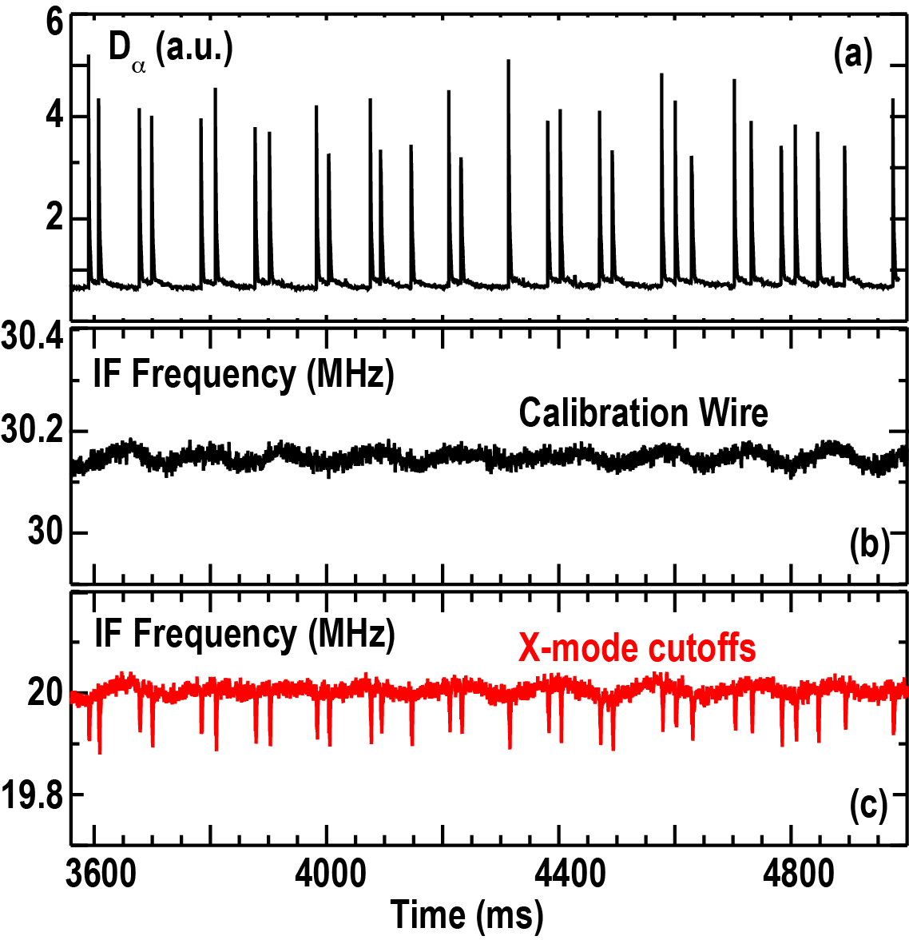

FIG. 7. For and ELMy H-mode discharge, a D signal in (a), while intermediate frequencies of V-band X-mode signal, reflected from the calibration wire in (b), and reflected from X-mode cutoffs in (c)

After this correction is applied to O and X-mode data for both the Q-band and V-band systems, the reflectometer density profiles are reconstructed as shown in Fig.8. As illustrated, the calibrated ne profile averaged from 4260 to 4300 ms is plotted in red with the standard deviation shown as error-bars (cross symbols). The density profile without real-time calibration is displayed as a blue line. In addition, the Thomson scattering density profile is also shown as green triangular symbols. There are no ELMs during this time window, so the ne profile shown in the figure is a typical H-mode ne profile. In the pedestal region, it can be seen that the wire calibrated profile is shifted ~ 3 mm compared to the standard phase calibrated one (see Fig. 8(b)). Although the position correction is quite small and the two measurements (Thomson scattering and reflectometer) remain in agreement within error bars, the wire calibrated reflectometer profile in the pedestal region is in slightly better agreement with the Thomson scattering ne data. The wire calibration method will continue to be used on DIII-D as a backup calibration method.

**V. Conclusions and future work**

In this paper, we describe a new free-standing wire technique providing a real-time profile reflectometer phase calibration capability during plasma discharges on DIII-D. The thin wire is installed near the end of the reflectometer transmission line, perpendicular to the reflectometer microwave propagation direction. Any reflectometer vacuum path length deviation during discharge is then simultaneously monitored via the retro-reflected signal from the wire. So, the plasma phase shift can be calibrated in real-time. It is found that the wire reflection signal is roughly constant when the normalized diameter is bigger than 0.2. Thereby, The diameter of wire has been optimized in the V-band system so that the in situ calibration is approximately independent of the probe beam polarization without interfering with the density profile measurement. For the long path length (~26 m) on DIII-D, the length deviation during plasma discharge is measured to be about 3 mm. With the real-time phase calibration, the reflectometer measurement accuracy is improved. In the future, we plan to employ this real-time calibration into profile analysis routinely. For the ITER low field side profile reflectometer where the path length and plasma durations are much longer and the environment more hazardous, it is expected that the path length changes could be much larger than on DIII-D. The technique described in this paper may be suitable for ITER and our demonstration on DIII-D may provide guidance for a similar approach on ITER.



FIG. 8. Reflectometer density profiles with error-bars over the time period =4280±20 ms. The blue line indications reconstructions performed without real-time phase calibration. The real-time phase calibration profiles are shown in red. An expanded pedestal view is shown in (b)

**Acknowledgements**

The work supported in part by the US Department of Energy under DE-FG02-08ER54984 and DE-FC02-04ER54698. DIII-D data shown in this paper can be obtained in digital format by following the links at https://fusion.gat.com/global/D3D_DMP.

DISCLAIMER: This report was prepared as an account of work sponsored by an agency of the United States Government. Neither the United States Government nor any agency thereof, nor any of their employees, makes any warranty, express or implied, or assumes any legal liability or responsibility for the accuracy, completeness, or usefulness of any information, apparatus, product, or process disclosed, or represents that its use would not infringe privately owned rights. Reference herein to any specific commercial product, process, or service by trade name, trademark, manufacturer, or otherwise, does not necessarily constitute or imply its endorsement, recommendation, or favoring by the United States Government or any agency thereof. The views and opinions of authors expressed herein do not necessarily state or reflect those of the United States Government or any agency thereof.

1L. Zeng, G. Wang, E.J. Doyle, T.L. Rhodes, W.A. Peebles, and Q. Peng, Nucl. Fusion **46**, S677 (2006).

2E.J. Doyle, et al, “Detailed System Design and Component Development for the ITER Low-Field Side Reflectometer System”, Proceedings of this conference (21st HTPD), 2016, Madison, WI.

3L. Zeng, W.A. Peebles, E.J. Doyle, T.L. Rhodes, N. Crocker, X. Nguyen, C.W. Wannberg, and G. Wang, Rev. Sci. Instrum. **85**, 11D843 (2014)

4E. J. Doyle et al., in Diagnostics for Experimental Thermonuclear Fusion

Reactors 2, edited by P. E. Stott, G. Gorini, and E. Sindoni (Plenum Press, New York, 1998), p. 119.

5K.T. McDonald, “Scattering of a Plane Electromagnetic Wave by a Small Conducting Cylinder”, <http://www.physics.princeton.edu/~mcdonald/examples/small_cylinder.pdf>

6G. Wang and W.A. Peebles, “Phase Calibration Concept Test Utilizing the DIII-D Profile FM Radar System”, ITER LOW-FIELD-SIDE REFLECTOMETRY PROJECT, 304171-R00011, General Atomics for PPPL