Accommodations – ITPA MDC Sept 19-22, 2023
San Diego, CA USA

Hotels
General Atomics is unable to reserve a dedicated hotel block at a conference hotel, due to the small number of attendees and uncertainty in the ability of registered attendees to attend in person (due to visa or other issues).

However, General Atomics has pre-negotiated preferred rates (corresponding to US government per diem, $161/night before taxes) at a number of local hotels. Those rates can be accessed by contacting the hotel, stating that you will be visiting General Atomics, and asking for the General Atomics preferred rate. The availability of these rates is subject to availability and very limited, so attendees are encouraged to make reservations as soon as possible.

A Google Map displaying the General Atomics preferred hotels & contact info is available HERE.

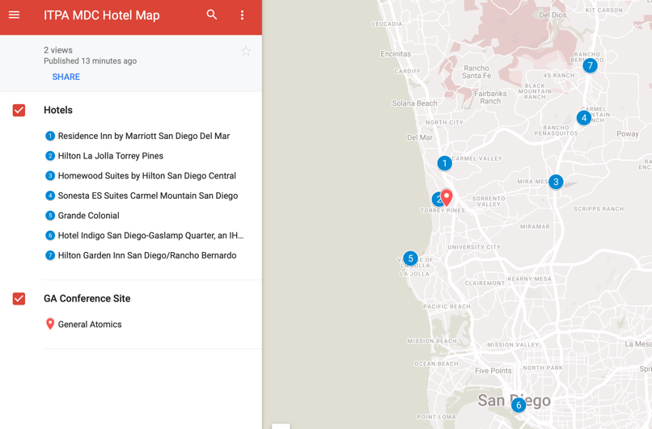
A simple search will bring up dozens of additional options.

Transportation
Conference Location = 3550 General Atomics Court, San Diego, CA 92121

There are several convenient options for transportation from your hotel to the conference site. The simplest are the app-based services accessed from your phone,
- Uber (Android, IOS) Requires credit card in app
- Lyft (Android, IOS) Requires credit card in app
- Ride Yellow (Android, IOS) Cash to driver or credit card, local taxi dispatch

You can also access the local taxi service by calling 619-444-4444.

